**MQTT IN ANDROID APPLICATION**

**Why MIT app inventor?**

MQTT is very simple to use, and you can build any android application in minutes by just dragging and dropping components. Also, the MIT app inventor has been very popular among the young kids who start with STEM education, as block programming helps them understand the programming concept.

**Introduction to MIT app inventor**

MIT app inventor window

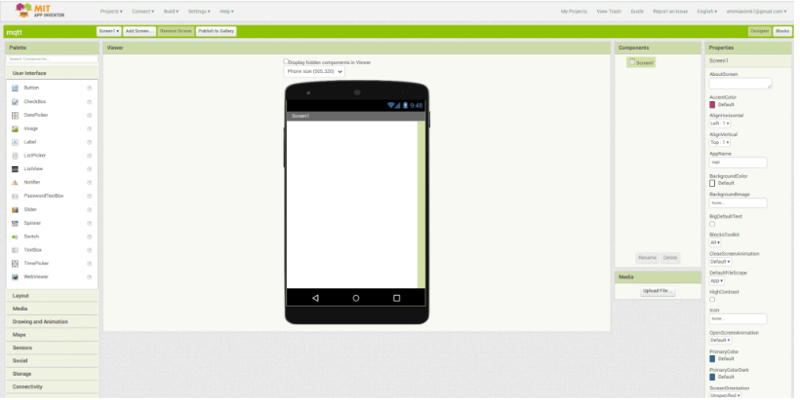

You can do the back-end development in the block menu, like how a specific button will behave when clicking on it.

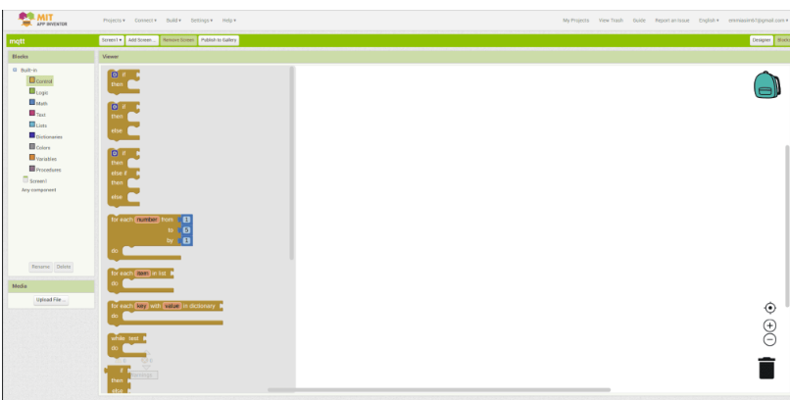

**Creating Layout**

By dragging a vertical layout in our screen, so all the items are in vertical arrangement and set the width of layout to fill-parent.

we will add a horizontal layout, and inside it, we will add a label to show the title MQTT dashboard, and in the right menu, you can play with parameters to adjust the size, width, height alignment, etc

We need to add a button for connecting to the MQTT broker. So, I will copy the same horizontal layout, and instead of the image, i will put a button. Then rename it to “connect” and change the label text as well.

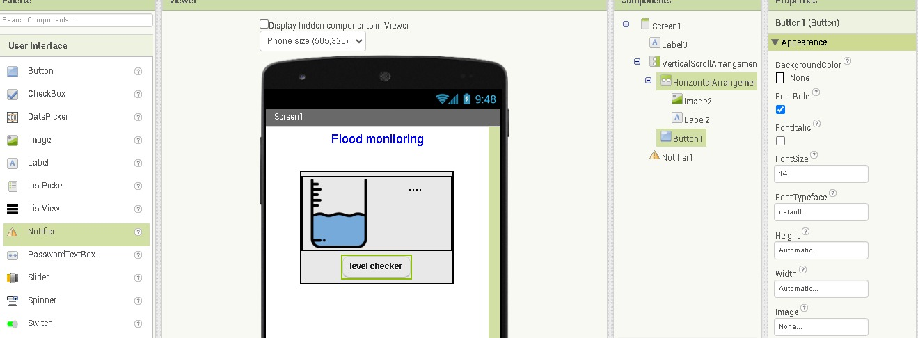

**Programming MQTT android app**

we have to download the MQTT expansion after the download the file wil it l shown in the zip file extract the file after we upload the file to the mit app inventor and then we have to move to programming in Mqtt android app and it will shows like..

To perform this program first opens your browser and type A12 MQTT expansion

Go to the website and download the package after the download upload the extracted zip file to your screen 1

Here the Link for the file :https://ullisroboterseite.de/android-AI2-PahoMQTT.html

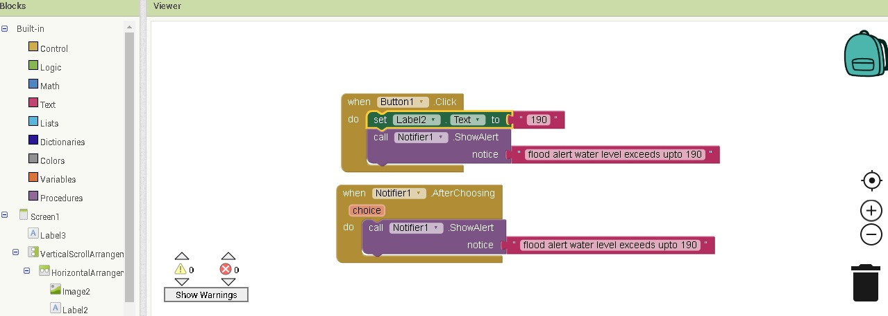

**Output**

Click on build and then android app (apk) , you will get two options either to dowload it or you can directly download from your android device by scanning the qr ciode

